# **Logic gates Practice**

A truth table shows the output values for a logic gate, based on a set of input values.

**Complete the truth table for an OR gate by entering either 0 or 1 in the output column:**

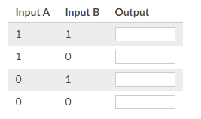

The diagram below shows an AND gate.



If the output wire is off (0), what are the possible states of the input wires?

👁️Note that there may be multiple answers to this question.

Choose all answers that apply:

1. Both inputs are 1
2. Both inputs are 0
3. Input A is 1, input B is 0
4. Input A is 0, input B is 1

A truth table shows the output values for a logic gate based on a set of input values.

Consider the following truth table:

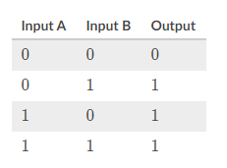

Which logic gate has a truth table that looks like that table?

Choose 1 answer:

1. AND gate
2. OR gate
3. Both AND and OR gates

When we're working with logic gates, we use multiple terms to describe the input and output values.

For each of the terms below, enter the corresponding binary value (0 or 1):

